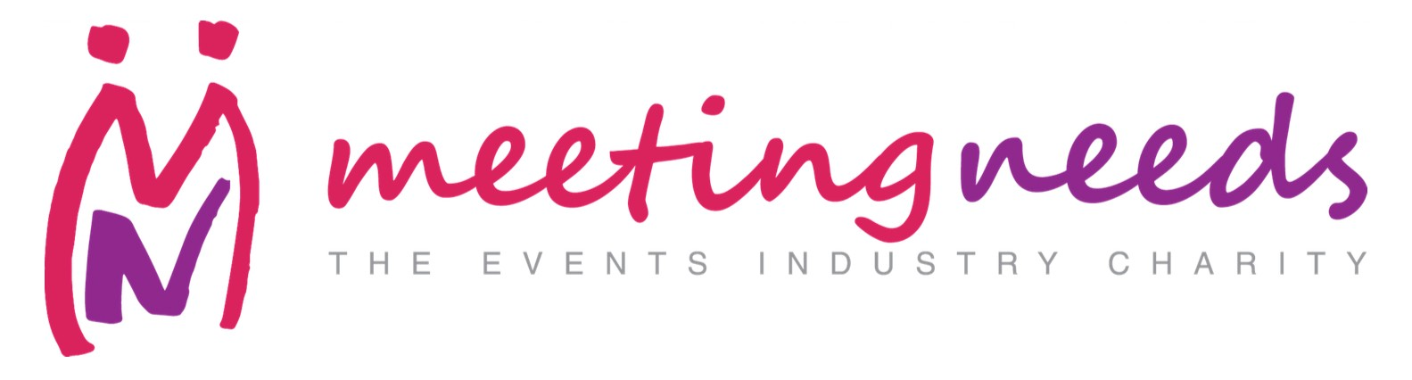

WHO WE ARE

Meeting Needs is the charity of the events industry
Meeting Needs was founded in 2004 by leading figures in the UK Meetings and Events industry. We bring together event professionals from across the industry, venues, agencies, corporates and suppliers to raise funds and change lives. Our causes unite all sectors of the industry; from live communications agencies to destination management companies.

Meeting Needs provides support to children and communities worldwide.
We raise money through the events industry, via Charity Partnerships and their fundraising initiatives to be able to provide support to small tangible projects that may not otherwise have access to funding; and that have a direct impact on the quality of life for children and communities all over the world.

WHERE WE ARE TODAY &THE FUTURE

Meeting Needs currently raises over £140,000 a year and supports over 40 projects annually with grants of up to £5,000 each. Our ambition is to do more; to help more; to galvanize the events industry behind a central vehicle ‘Meeting Needs’ to change more lives.

We’d like to triple our reach within the next two years; connecting more people within the industry and being able to double the number of projects we support.

OUR BENEFICIARIES

These are just a few examples of the projects and individuals we have been privileged to help recently;
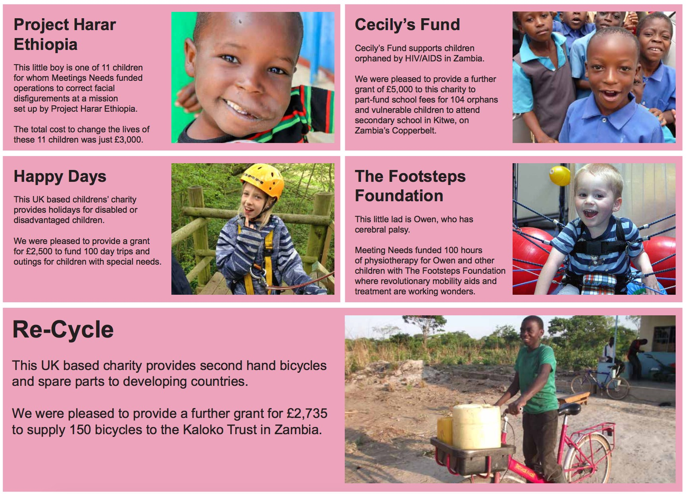

HOW YOUR ORGANISATION CAN HELP

To do this we’d like to ask you to join us and become a Charity Partner. Charity Partners are a community of supporters that show a base level of commitment (£50 per month, payable quarterly or annually) but also who get involved in fundraising initiatives and fundraise for Meeting Needs.

WHAT’S IN IT FOR YOUR ORGANISATION?

As a Charity Partner, you get to be a central part of the Event Industry charity and share in our growth story.
- Leveraging your engagement with Meeting Needs as part of your corporate CSR strategy, we can provide you with case studies to share, help find a specific project for your organization.
- We can get a Meeting Needs Board Member to act as your Charity mentor
- We offer opportunities to feature in our updates to our Charity Partner network of 65 event industry professionals;
- We re-­‐share as much of your charity news and events via our social media channels as we can; and link to you from our website
- We try to prioritise funding and match-­‐funding applications for Charities supported by Charity Partners (provided those charities match our funding criteria)
- We offer opportunities to join industry fundraisers for Meeting Needs such as Royal Parks Half Marathon, Prudential Ride London 100 etc.
As a Charity Partner, we provide you with certificate for your premises and an email signature strip to evidence your CSR as a Charity Partner of Meeting Needs; and are happy to provide stories of our beneficiaries for your internal presentations and external sales pitches.

HOW OUR CHARITY PARTNERS FUNDRAISE FOR US

Charity Partners fundraise at their events, or hold events to fundraise for us. Please see some examples below;
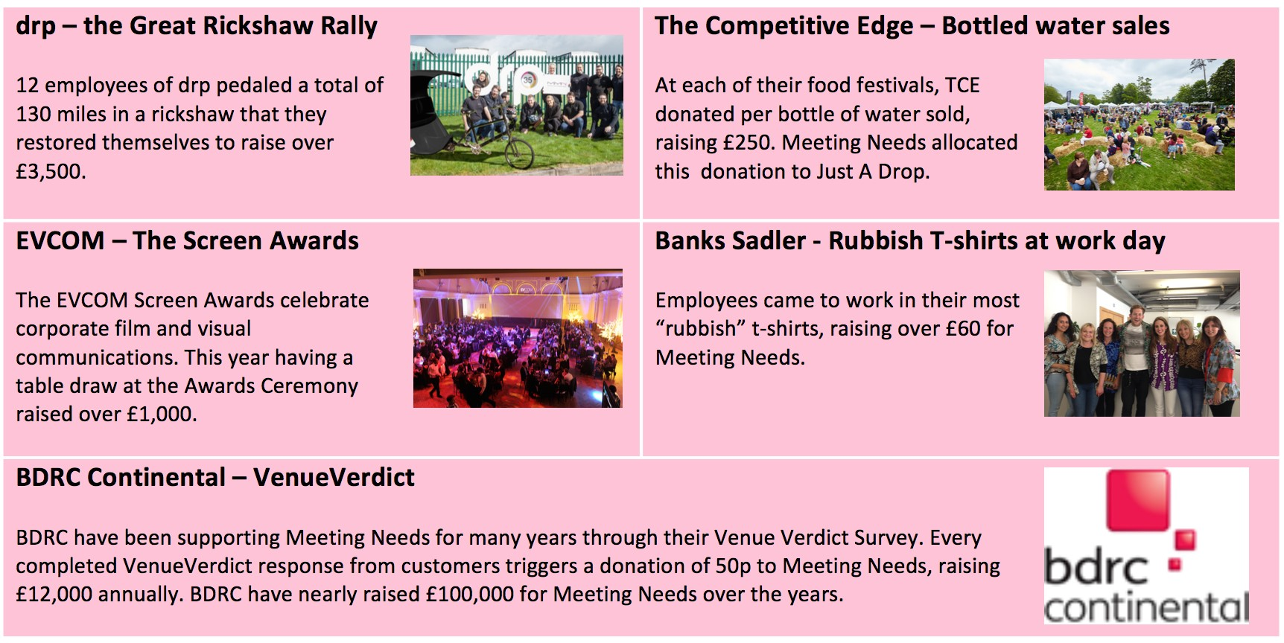

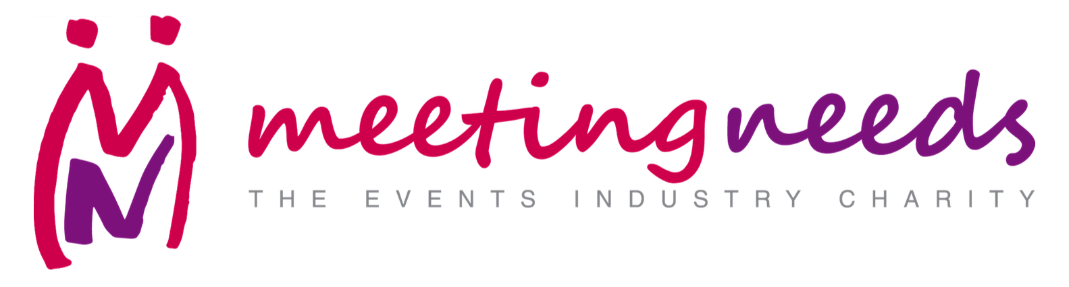

CHARITY PARTNER APPLICATION FORM

Please complete and return this form to:
Margaret Mann c/o Meeting Needs
58 Southwark Bridge Road, London SE1 0AS,

Email: mmann@meetingneeds.org.uk
Website: www.meetingneeds.org.uk
Telephone: 020 7593 1723

☐ We would like to become a Charity Partner at £600 per annum
Signature: | Date:
Contact Name:
Position:
Organisation:

If different from above
Organisation Name for MN Website:

Organisation Name for Invoice:
Address:
 | Post Code:
Tel: | Fax:
E-mail:
Website:
Where did you hear about Meeting Needs?

Payment options:

☐Please find enclosed cheque to the value of £600
☐Please invoice my organisation for the amount of £600
☐ I have paid by BACS using the bank details below, for the amount of £600
☐ I have set up a quarterly Standing Order for the amount of £150 starting on (date )
☐ I have set up an annual Standing Order for the amount of £600 starting on (date )

Bank name: HSBC
Account name: Meetings Industry Meeting Needs
Sort code: 40-20-09
Account number: 21480537

Social media details
Facebook:
LinkedIn:
Twitter:
Instagram:

