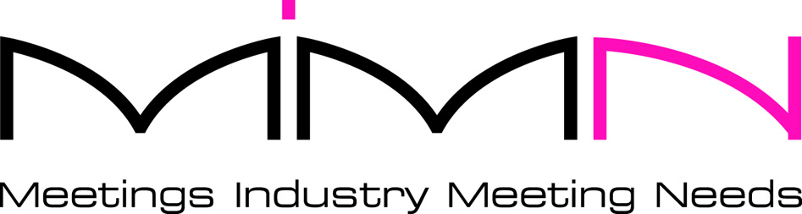

CHARITY PARTNER APPLICATION FORM

Please complete and return this form to: Kate Conway, Charity Partner Liaison Officer, Meetings Industry Meeting Needs, Apple Tree Cottage, 19 Brook St, Watlington, Oxfordshire, OX49 5JH.

Email: kconway@meetingneeds.org.uk Website: www.meetingneeds.org.uk

We would like to become a Charity Partner at £600 per annum

Signature……………………………………………………………… Date…………………………
Contact Name…………………………………………………………………………………………..
Position………………………………………………………………………………………………….
Organisation…………………………………………………………………………………………….

If different from above
Organisation Name for MIMN Website………………………………………………………………

Organisation Name for Invoice………………………………………………………………………..
Address………………………………………………………………………………………………….
………………………………………………………………………... Post code…………………….
Tel………………………………………………….. Fax………………………………………………
E-mail…………………………………………………………………………………………………….
Web site………………………………………………………………………………………………….
Where did you hear about Meeting Needs?................................................................................

Payment options:
Please find enclosed cheque to the value of £600
Please invoice my organisation for the amount of £600
I have paid by BACS using the bank details below, for the amount of £600
I have set up a quarterly Standing Order for the amount of £150 starting on (date)..………….………
I have set up an annual Standing Order for the amount of £600 starting on (date).…………………...

Bank name: HSBC
Account name: Meetings Industry Meeting Needs
Sort code: 40-20-09
Account number: 21480537

Social media details
Facebook page……………………………………………………………………………………….
Twitter handle…………………………………………………………………………………………
LinkedIn profile……………………………………………………………………………………….

